Name:

Polytheism in Ancient Mesopotamia (the time of Sumer kingdom)

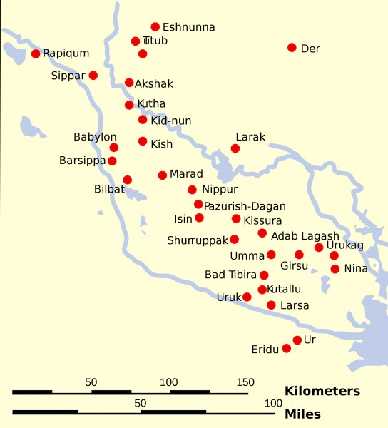
Take a look at the map below and answer the questions about Sumer.

- What is true about the location of almost all of the city-states of Sumer?

- What resources do they have in common?

- How might these common resources have led to conflict?

Religion in Sumer
Resources weren’t the only thing shared by the people of Sumer, they also had a common religion. As you watch the video assigned to you in Discovery Education, complete this chart.

Things represented by the gods of Sumer | How the people worship daily | How the priests and kings impact daily life | The purpose and uses of the Ziggurat

After watching the video and completing the chart, explain how the people of Mesopotamia/Sumer were impacted by their religion in the space below:

How is the Sumerian’s practice of religion similar to/different from other religions that you know of or believe in?

Sumer’s religion is similar to other religions I know by….. | Sumer’s religion is different from other religions I know by….

**When you are done, save your work, and print this document.

**Prepare for your weekly quiz. You will be quizzed on: polytheism, monotheism, mummification, ka, natron, afterlife, reasons for mummification, impact of religion in Sumer, and Ziggurat.

