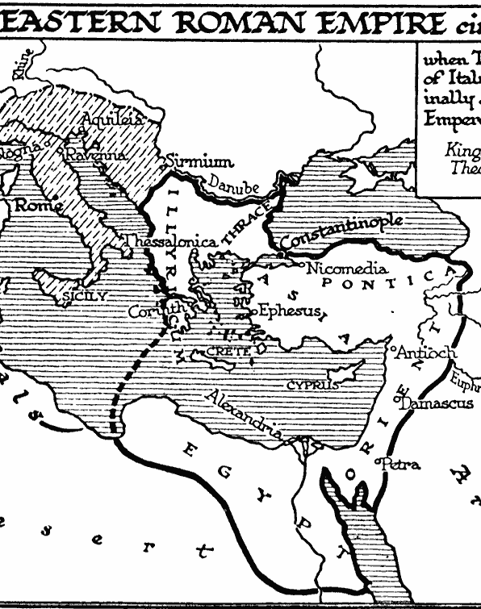
The Justinian Code and the North Carolina Code

Directions: Read each scenario. Open the QR code reader app, which will scan
the codes and take you to the websites.
- Read the law that applies to it in the Justinian Code.
- Read the Law that applies to it in the North Carolina Code.
- Answer the questions on the notebook page beneath this handout.

Justinian Code: http://www.fordham.edu/halsall/basis/535institutes.asp
North Carolina Code: http://statutes.laws.com/north-carolina

Scenario 2: Adoption

Flavia and Maximus have decided to adopt a child. Flavia is 26, Maximus is 25, and the child, Constanius, is 15.

- Could they adopt this child in the Byzantine Empire? Explain.
- Could they adopt this child in North Carolina? Explain.

Justinian Code: 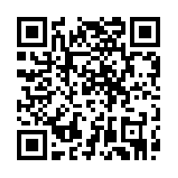 North Carolina Code:

Scenario 1: Marriage

Flavia and Maximus met at a quiet resort in Crete. They spent the entire week getting to know one another and fell in love. Maximus proposed marriage to Flavia, and she said, “Yes.” When they returned to Constantinople, they discovered that their fathers were long lost brothers.

- Could they marry in the Byzantine Empire? Explain.
- Could they marry in North Carolina? Explain.

Justinian Code: 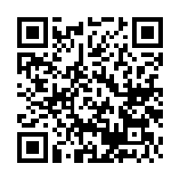 North Carolina Code:
Scenario 3: Murder

One day, Maximus was sawing the branches off of trees that hung over the sidewalk in front of his yard. Maximus forgot to put a sign on the sidewalk warning his neighbors of falling branches. His neighbor, Gaius, was out for a morning stroll when one of the branches struck and killed him.

- Is Maximus guilty of murder in the Byzantine Empire? What punishment (if any) might he receive? Explain.
- Is he guilty of murder in North Carolina? What punishment (if any) might he receive? Explain.

Justinian Code: 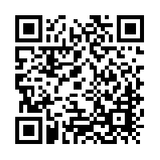 North Carolina Code: 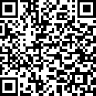
*Find “The Lex Aquilia” section *Use all of these to help you.
Helpful Definitions:
Simple Assault- a type of assault (harm or offensive contact with a person) that was not provoked OR did not cause any physical harm.
Adoption- to legally bring up someone else’s child as your own
Murder-the unlawful (illegal) and premeditated (planned to do it) killing of one human by another.
Felony-a crime, usually with violence, that is the more serious than other crimes (misdemeanors) and usually punishable by death of imprisonment.
Misdemeanor-a minor wrongdoing; an offense less serious than a felony
Scenario 4: Assault

When Maximus was serving time for the tree incident, Flavia went to the market every day at noon. One day, Gaius’s widow saw her there and began yelling at her and calling her a murderer. A crowd gathered, and Flavia could not run away.

- Is Gaius’s widow guilty of assault in the Byzantine Empire? Explain.
- Is she guilty in North Carolina? Explain.

Justinian Code: 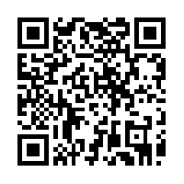 North Carolina Law:
*Find “Injuria” section

