Social Studies Name _________________________________
Religion Unit Date __________________________________

Polytheism Fact Sheet
Polytheism - _____________________________________________________________________________
Poly - a prefix meaning _________________________________________
Theo - a Greek word meaning ____________________________________
“ism” - a suffix meaning _________________________________________
For each of the Ancient Civilizations that had polytheistic beliefs, complete the questions:
Sumerians
When did they live? ________________________________
What did they believe in? _______________________________________________________________

____________________________________________________________________________________
List at least four of their gods or goddesses:
Name of god/goddess | What were they in charge of?

What were some of their religious practices or rituals? __________________________________________

_______________________________________________________________________________________

Egyptians
When did they live? ________________________________
What did they believe in? _______________________________________________________________

____________________________________________________________________________________
List at least four of their gods or goddesses:
Name of god/goddess | What were they in charge of?

What were some of their religious practices or rituals? __________________________________________

_______________________________________________________________________________________

India - Hinduism
When did they live? ________________________________
What did they believe in? _______________________________________________________________

____________________________________________________________________________________
List at least four of their gods or goddesses:
Name of god/goddess | What were they in charge of?

What were some of their religious practices or rituals? __________________________________________

_______________________________________________________________________________________

Greeks/Romans
When did they live? ________________________________
What did they believe in? _______________________________________________________________

____________________________________________________________________________________
List at least four of their gods or goddesses:
Name of god/goddess | What were they in charge of?

What were some of their religious practices or rituals? __________________________________________

_______________________________________________________________________________________

Mayans
When did they live? ________________________________
What did they believe in? _______________________________________________________________

____________________________________________________________________________________
List at least four of their gods or goddesses:
Name of god/goddess | What were they in charge of?

What were some of their religious practices or rituals? __________________________________________

_______________________________________________________________________________________

Aztecs
When did they live? ________________________________
What did they believe in? _______________________________________________________________

____________________________________________________________________________________
List at least four of their gods or goddesses:
Name of god/goddess | What were they in charge of?

What were some of their religious practices or rituals? __________________________________________

_______________________________________________________________________________________

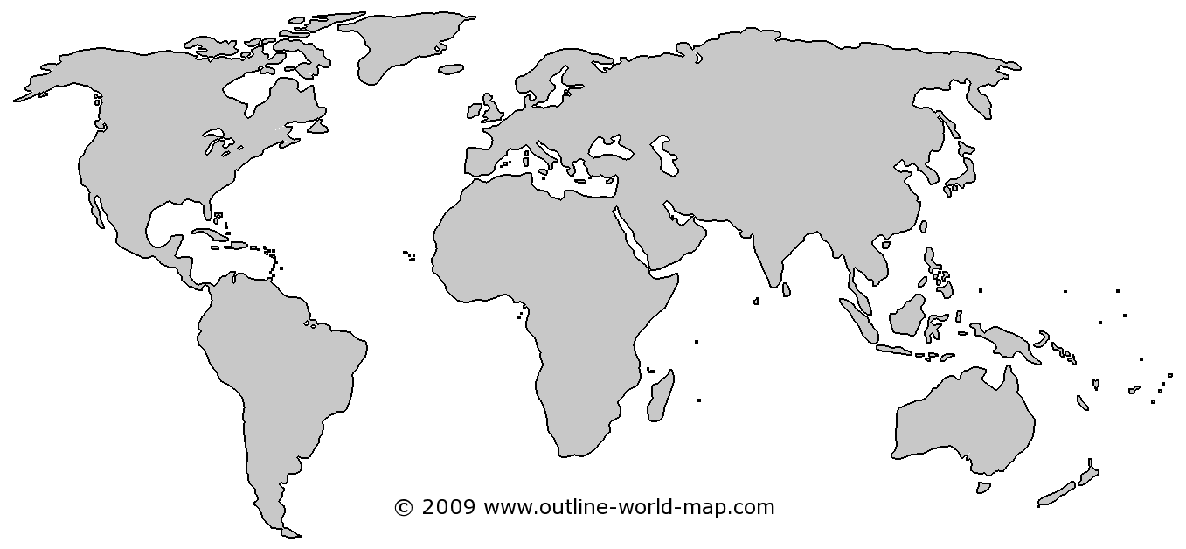

On the map above, mark the location of each of the six ancient civilizations that practiced polytheism.
(Sumeria, Egypt, India , Greece/Rome, Maya, Aztec)

