Why People Should Not Watch Too Much Television
Topic Sentence
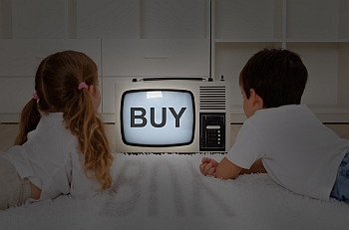
Watching television is an experience shared by most adults and children. It is cheap, appealing, and within the reach of the general public. In this way, TV has become an important mass media around the world. Sadly, this resource isn’t used in a way that people could get the best possible benefits from it. The purpose of this essay is to persuade the reader that people shouldn’t watch too much television because the content of many TV programs is not educational; it makes people waste time that could be used in more beneficial activities; and it negatively affects people’s mental development.
3
2
1
Thesis Statement
The first reason why people shouldn’t watch too much television is because the content of many TV programs is not educational. Nowadays, we can see movies, series, and shows that present scenes of violence, sex, and drugs. This has established wrong concepts among the audience that influence them into having a negative behavior. Moreover, the impact this tendency has on children is worse because they grow up with the idea of a world where women must be slender and blonde to stand out, where problems can only be solved with money and violence, and where wars are inevitable.
The second reason why people shouldn’t watch too much television is because it makes people waste time that could be used in more beneficial activities. The time we spend watching TV could be applied to useful activities like exercise, reading, interacting with friends and family, activities that are a crucial for a healthy lifestyle.
The third reason why people shouldn’t watch too much television is because it negatively affects people’s mental development. According to several scientific studies, watching TV for prolonged periods of time has a negative effect over the intellectual development of children and leads to deterioration of the mental capacity in older people by causing both attention and memory problems in the long term.
In conclusion, people shouldn’t watch too much television because the content of many TV programs is not educational; it makes people waste time that could be used in more beneficial activities; and it affects people’s mental development. However, this doesn’t mean that we should ban TV, but if we are going to watch it, we should do it with moderation. Television is a resource that we should learn to use through the right selection of programs by taking an active and critical attitude towards it.
Restated thesis

