Why Should You Become a Vegetarian?
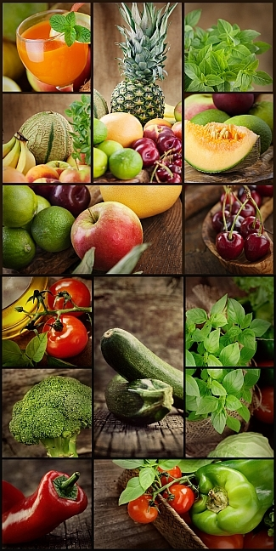
Vegetarianism has become the most popular diet among the young generations facing the new millennium. This discipline eliminates the intake of meat and in some cases also the consumption of dairy products and eggs. Are there enough reasons to make you change your eating habits? My purpose is to prove that vegetarianism is the diet that offers more benefits to our health, spirit, and society.
Nowadays, health is the number one individual and governmental concern. Health is a fragile factor, and its behavior relays mostly on the nutritional quality of the food we ingest. A balanced non-vegetarian diet allows the consumption of all four main food groups including meat and other animal by-products that are important protein and fat sources. Most of us consume more proteins and fats than we need. An excess of proteins can cause kidney failure and/or osteoporosis, and a high-fat diet can eventually lead to heart disease, cancer, obesity, and diabetes. On the other hand, vegetarians get protein from grains, beans, vegetables, and low-fat food. This is how they reduce the risk of most diseases caused by fats. It is a myth to believe that vegetarians don't get enough proteins or that their diet is not balanced because they don't eat meat. The key is variety and accurate combinations of energy and protein sources.
If I were asked to describe a vegetarian, I would immediately mention they are very disciplined people. It has been proved that there exists a remarkable correlation between the people who succeed and people who follow a disciplined lifestyle. People who are faithful to the disciplines they have acquired show integrity, a remarkable behavior, and they are usually in a good mood. Vegetarians, always concerned about quality and discipline, develop a greater social responsibility that motivates them to improve their environment.
Moreover, environmental issues have been capturing public attention because of their relevancy and increasing deterioration of our quality of life. If you are concerned about the environment, consider that massive meat production can have a negative impact on tropical rain forests, soil stability, and air and water quality. Large extensions of forests have been cut and changed into grasslands that provide cattle with food. To conserve grasslands, fertilizers and other chemical substances are used; consequently, soil and water resources are polluted. Even though there are methods that avoid this kind of deterioration, producers prefer to ignore them so they can keep satisfying the increasing meat demand without affecting their production rates.
Vegetarians' life spans are increased and through this discipline they learn to live quality in all the possible aspects. Besides, their beliefs are congruent with their lifestyle and they take responsibility and action for problems within their own bodies and in their surroundings. Take a look at yourself. Is your health at risk? Have you been able to reach your goals? Are you a factor of change and improvement within your society? You must at least try becoming a vegetarian now that you know it is a tempting challenge and an exciting experiment that has advantages and no risks. Do it for your body, for your lifestyle, or for your environment, but do it. Stop letting others have all the credit, the fun, and the quality.

