Middle Ages Study Guide
Part 1: I understand characteristics of the Middle Ages. ISN p. 92
- There was no central ____________.
- Europe lost a lot of its technology and ____________________________.
- Only the ________ in churches could read and write.
- Most of the ______ & _____ classics were lost.
- Compared to Roman times, during the Middle Ages:
In these 3 sentences, circle the correct BOLD word.
  - The standard/quality of living was higher/lower.
  - More/Fewer people could read and write.
  - The Catholic Church had more/less power.
Part 2: I know what the Medieval Times are and when they happened. ISN p. 93
- Medieval Times= the time from the fall of _______ to before the _______________.
- The 3 eras of the Medieval Times are:
______________________, then _____________________, then ___________________
Part 3: I understand the impact of geography on the Middle Ages. ISN p. 96
- The main Medieval cities are all built near ____________.
- One benefit/advantage to being near bodies of water is ___________________________.
- One disadvantage to being near bodies of water is that it led to _____________________.
Part 4: I understand feudalism and manorialism and why they were created. ISN p. 98-100
- A vassal is a person ________________________________________________
- Feudalism was the system popular in ___________ Europe from _____ to _____.
- This system made the ______ richer and the ______ poorer.
- Feudalism was created because rulers couldn’t protect kingdom from _______________.
- __________ serves ___________ who serves __________ who serves the King.
- The manor was isolated, like its own little village. True/False
- Serfs were also called slaves. True/False
- In exchange for working, serfs were given protection & a place to life. True/False
- The lord didn’t do much fighting. True/False
- If you worked hard enough, you could move to a higher social class. True/False
- Knights were expected to follow the code of shivers. True/False
Part 5: I know about Charlemagne, what he did for Europe during the Middle Ages, and that after he died things quickly went back to the way they were before him. ISN p. 104
- Charlemagne worked hard to unite the Germanic ___________.
- He was known as King of the __________ and was crowned Holy Roman ___________.
- Charlemagne is one of the big reasons for the continued spread of __________ throughout Europe and a reason why the Church became so popular in the Middle Ages.
- In addition to being the father of 18 children, he is also referred to as the ________ of Europe because he was the first ruler to try to bring the ___________ together.
Part 6: I understand the Black Death, including its symptoms, causes & effects. ISN p. 105
- The Black Death is also referred to as the Black _________.
- Some of the FALSE causes of the Black Death include bad _____, _____ (meow), or ______ (type of people).
- The ACTUAL cause of the Black Death were the _______ that lived on rats.
- The Black Death came from ____________.
- The Black Death affected Europe’s population because __________________________.
- Why did this mean that peasants/serfs could ask for more pay/money?
- Can explain the connection between this children’s nursery rhyme and the Black Death:
Ring-a-round the rosie,
A pocket full of posies,
Ashes! Ashes!
We all fall down.
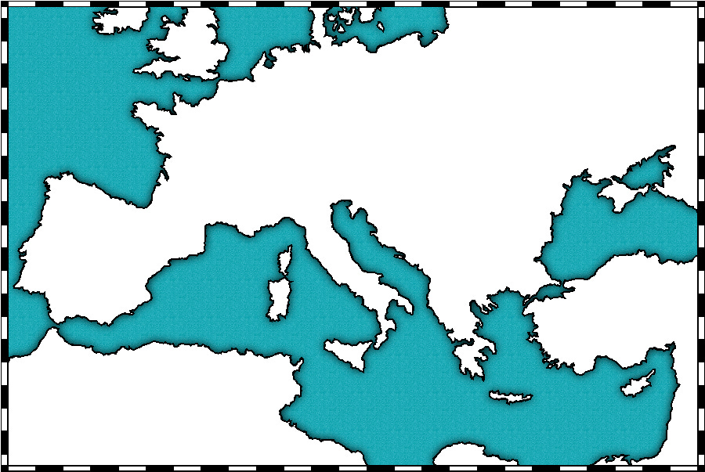
Part 7: I understand geography & various events of the Middle Ages show up on maps.
I can do the following things to this map:
- Label the Mediter-
ranean Sea
- Label Rome
- Shade Western Europe (were feudalism took place)
- Draw arrows showing where each of the 3 barbarian groups were invaded Europe from (what directions).
- Draw a symbol on the map indicating the location of the origins of the Black Plague (where it is coming from). This symbol can be a rat, skull, dead person, etc.
Part 8: I can show my understanding of the Middle Ages by looking at charts, graphs, or maps of information and knowing what is being shown.
You might see a chart, graph, infographic, or table on the test. It can be on any of these topics:
Feudalism social order, manor system, Black Death statistics, Charlemagne’s reforms/changes

