Global Scrumptious Veggies
Location: Mumbai, India Population: 22 million
School: DR SARVEPALLI RADHAKRISHNAN VIDYALAYA
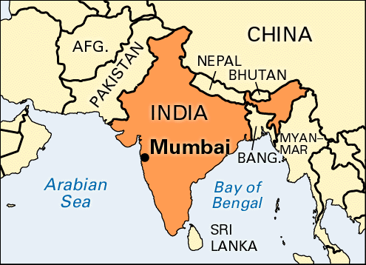
Brief Description: Explore and create some global salads & collaborate with a school in another country.
Overview of Activity
Day 1 | - Find information on different Indian and Italian salads.  - Analyze various Indian and Italian salad recipes.
Day 2 | - Prepare a PowerPoint presentation in groups that highlight the nutritional values of ingredients used in salads of both the countries.
Day 3 | - Use knowledge about ingredients, etc. to prepare one of the two salads in our Global Salad Party.  - (Teacher judges) Evaluate the salads created
Day 4 | - Complete feedback and evaluations  - Send video to school (Skype?)

Scrumptious Veggies Day 1
Anticipation Guide: answer the following statements with a true or false.
Before Activity | Statement | After Activity
 | - Salads generally use the same ingredients.
 | - Banana is a common ingredient in an Italian salad.
 | - Cucumber is an ingredient found in some Indian salads.
 | - Salads are an important part of your daily diet.
 | - India and the United States of America have about the same population.
 | - Mumbai is the capital of India.

Quick Write: answer the following question
Why do countries use different ingredients in their salads?

Explore Indian and Italian Salad Recipes
Use the PowerPoints on my website to complete the following activities.
Italian Salad
*Write the type of Italian salad (many types) and the different food ingredients found in it.
Type of Salad | Ingredients Included
Indian Salad
Type of Salad | Ingredients Included

