Name _______________________________ Period _______
Week 3 Quiz Study Guide
Directions: study the terms and their definitions below for the quiz.
- Culture – the way of life a society creates to fulfill its needs.
- Cultural Change – changes that affect the way people live.
- Inventions – new technology
- Cultural Diffusion – spread of something in one culture to another culture/society.

Directions: know the 6 culture patterns below for the quiz.
- Economic
- Political
- Family
Cover this with your hand and see if you can say all 6 from memory!
- Religious
- Educational
- Artistic

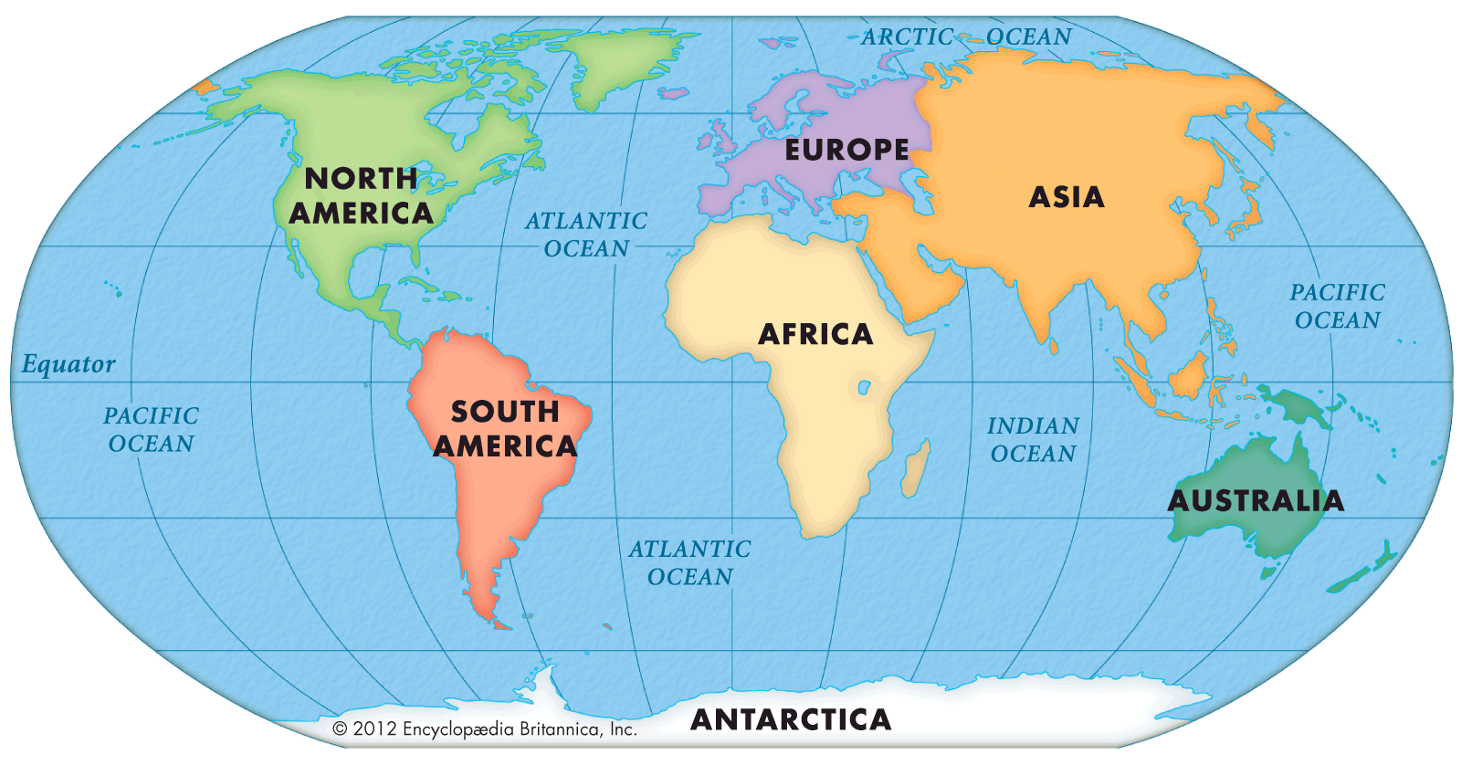
Directions: be able to place the 7 continents and 4 oceans on a map.
Practice placing the continents and the oceans in the correct place by filling in the world map on page 14 of your ISN.

How You Will Be Graded:
- Each word at the top is worth 10 points for a total of 40. 40
- The 6 culture patterns are worth 5 points each for 30 points. 30
- The completed world map is worth 11 points. 11
- Having your grade tracker will be worth 10 points. 10
- Having your completed agenda book will be worth 9 points. 9
100

