Common Core Lesson Plan

Topic: Ancient North America Title: Who were the First Americans?

Resources
- http://www.time.com/time/classroom/glenfall2006/pdfs/who_were_the_first_americans.pdf
- Guiding Questions for article “Who Were the First Americans?”
- Guiding Questions for article “Who Were the First Americans?” (modified)
- As You Read handout
- As you read handout (modified)
- Menu Activity for article “Who Were the First Americans?”
- Migration Map and questions
- Kennewick Man excerpt for Collaborative Annotation activity
- Kennewick Man gallery walk questions
- “Three Level Notes” Graphic organizer for article excerpt

Common Core Standards

WHST 1, 4-6, 9–10
RH 2, 4-8

Essential Standards

6.H.1.3 - Use primary and secondary sources to interpret various historical perspectives

6.H.2.1 - Explain how invasions, conquests, and migrations affected various civilizations, societies, and regions.

6.G.1.2 - Explain the factors that influenced the movement of people, goods and ideas and the effects of that movement on civilizations, societies, and regions.

6.G.1.4 - Explain how and why civilizations, societies, and regions have used, modified, and adapted to their environments.

6.G.2.1 - Use maps, charts, graphs, geographic data, and available technology tools to draw conclusions about the emergence, expansion, and decline of civilizations, societies, and regions.

6.C.1.1 - Analyze how cultural expressions reflected the values of civilizations, societies, and regions.

Background Information
- Students will, during the course of the fourth and fifth grade curriculum, have developed an understanding of basic geographic concepts including the Five Themes of Geography.

- Students will, during the course of the fourth and fifth grade curriculum, have become familiar with the various Native American groups that populate North America.

- Students will, during the first units of study in Grade 6, develop an understanding of the Social Sciences, particularly history, anthropology and archaeology.

Instructional Sequence (before, during, and after instruction)

Step 1

Display the map of North American migrations (without showing the questions). Ask students for their thoughts on the map. What is the topic of this map? What do you already know about this topic? Lead the students in a discussion of migration as it relates to the theme of Movement, in order to activate prior knowledge. Discuss reasons people migrate. Lead the discussion so as to be able to transition to the article.

Step 2

Display the Time article “Who Were the first Americans?” Lead students in a brief pre-reading exercise as you scan the article. Distribute the Guiding Questions handouts and the Modified Guiding Questions handouts. Instruct the students to read the article and write their answers to the Guiding Questions. Have students share their responses to the Guiding Questions with a partner as you circulate and monitor participation.

Step 3

Distribute the “As You Read” handout and the modified “As You Read” handout. Instruct the students to carefully read the article and record their answers to the questions. Circulate and monitor participation. Either discuss the answers in a whole class setting or collect written responses as a formative assessment.

Step 4 (Choose A or B)

A. Make enough copies of the Kennewick Man excerpt to be able to provide one copy for every three
students. Mount each copy on a large piece of chart paper, in effect creating a very large margin around the excerpt. Distribute chart paper/excerpts to groups of three students and instruct them to write comments, questions, impressions, feelings, etc. in the margins.
After each group has had sufficient time to annotate their article, direct students on a gallery walk to examine each group’s annotations. Distribute “Kennewick Man gallery walk questions” handout. Instruct students to record their responses to the questions as they circulate from group to group. Either discuss the responses in a whole class setting or collect written responses as a formative assessment.

-or-

B. Distribute a copy of the excerpt and the “Three Level Notes” Graphic organizer” handout to each student and allow the class time for individual reading and note taking. Either discuss the responses in a whole class setting or collect written responses as a formative assessment.

Step 5

Assign the “Who Were the First Americans” Menu as a summative activity for the lesson.

Guiding Questions for article “Who Were the First Americans?”

1. What discovery is discussed in this article?

2. Why has this discovery created controversy among archaeologists?

3. How do you expect this controversy to be resolved?

Guiding Questions for article “Who Were the First Americans?” (modified)

1. This article is about the discovery of a _____________________, called “________________________Man”.

2. This skeleton has caused scientists to wonder ____________________________________________________
___________________________________________________________________________________________
___________________________________________________________________________________________
___________________________________________________________________________________________
___________________________________________________________________________________________
___________________________________________________________________________________________
___________________________________________________________________________________________
___________________________________________________________________________________________
___________________________________________________________________________________________

3. In order for the scientists to solve this mystery____________________________________________________
______________________________________________________________________________________________________________________________________________________________________________________
___________________________________________________________________________________________
___________________________________________________________________________________________
___________________________________________________________________________________________
___________________________________________________________________________________________
___________________________________________________________________________________________
___________________________________________________________________________________________

As You Read Handout

Paragraph 1

1. Explain why you think the county coroner called a forensic anthropologist to examine the skeleton.

2. When Jim Chatters’ guess is called “off the cuff”, the author is using a type of figurative language known as an _____________________.

3. Why did the spear point cause Jim Chatters to question the age of the skeleton?

Paragraph 2
4. Use context clues to define or write synonyms for:
Antiquity -
Fragmentary -
Crucial -
Colonized -
Murky –

5. The word epochal is used to describe an event or time period that is so important that it is used as a reference point for other events or time periods. Name another epochal event from any point in history.

Paragraph 3
6. Why do the authors say that it is remarkable that Kennewick man was buried deliberately?

Paragraph 4
7. How does the existence of Kennewick Man lead to the question “Who really discovered America”?

Paragraph 5
8. Explain what is meant by a “blue ribbon” panel -
9. Use context clues to define or write synonyms for:
Excavating -
Skepticism -
Affirmed –

Paragraph 6
10. What type of evidence do the authors cite to support the claim that the first Americans came from Siberia?

Paragraph 7
11. Do you agree with the statement that the remains of people will be the most valuable evidence? Why? Why not?

As You Read Handout (modified)

Paragraph 1

1. Forensic Anthropologists use scientific methods to help solve crimes. Explain why you think the county coroner called a forensic anthropologist to examine the skeleton.

2. The author uses an idiom in this paragraph. Choose the phrase that is an idiom:
a. the bones were obviously old b. off the cuff c. a man who had walked the banks of the Columbia

3. The bone spear point caused Jim Chatters to assume the bones were much older because ______________
_____________________________________________________________________________________.

Paragraph 2
4.Match the synonym/definition to one of the words
5. Epochal events are so important that other events are referred to in comparison to them. Which of these events could be described as “epochal”?
a. astronauts land on the moon
b. terrorist attacks on 9/11/2001
c. the birth of Jesus
from Paragraph 2:
Word from Paragraph 2 | Synonym/Definition
 | Ancient times
 | Very important
 | Settled
 | Unclear
 | Partial

Paragraph 3
6. Since Kennewick man was buried deliberately he was probably part of a _________________________.

Paragraph 4
7. When Kennewick Man was discovered, some scientists began to think they may have been wrong about
____________________________________________________________________________________.

Paragraph 5
8. Blue ribbons are often awarded as prizes. Why do you think the authors use that term to describe the panel of researchers? ___________________________________________________________________

9. Match the synonym/definition to one of the words from Paragraph 5:

Word from Paragraph 2 | Synonym/Definition
 | Approved
 | Digging up
 | Doubt
 | Inner area

Paragraph 6
10. genetic evidence suggests that the first Americans came from ______________________.

Paragraph 7
11. The authors claim that the bones of ancient people will help solve the mystery of the first Americans. Do you agree? Why? Why not?

Menu Activity

Who Were the First Americans?
Answer any combination of questions with a point total equal to or greater than 25.

1 point questions:
1. Kennewick is a __________________ in Benton County, Washington.
2. A 9,000 year old skeleton came to be known as _____________________________.
3. Scientists estimated that the skeleton is from a man who was about _____________________ tall.
4. The discovery of Kennewick Man made some scientists wonder if the ___________ people were really the
First Americans.
5. An archaeological site in Chile called ___________________ also suggests that people came to the
Americas much _____________ than was previously thought.
6. To solve the mystery of the first Americans, scientists hope to find more _______________________.

2 point questions:
7. What can you infer from the fact that scientists have found very few skeletons as old as Kennewick Man?
8. What do you think would happen if a much older skeleton was found in North Carolina?
9. Describe some of the methods archaeologists use.
10. What is the main idea of this article?
a. the first Americans most likely came from the Lake Baikal region of Russia
b. Monte Verde in Chile is the oldest human settlement in the Americas
c. new discoveries are causing scientists to reconsider their theories about the first Americans

3 point questions:
11. How would you attempt to solve the mystery of the first Americans?
12. What examples can you find in this article that suggest that the first Americans came from Russia?
13. How would you change this article to make it easier for 6th graders to understand? Be specific.
14. How could the authors explain this mystery, other than a magazine article. What would it look like?

4 point questions:
15. Outline the main points that suggest that the first Americans were here before Clovis.
16. What type of graphic organizer would be most useful to help you understand this article? Why?
17. Compare the discovery of Kennewick man with the Monte Verde site. Which was a more valuable find?

5 point questions:
18. Rate the top three arguments for Americans arriving before Clovis.
19. What advice would you give to a person who discovered an old skeleton?
20. Select the most important discovery;
a. Kennewick Man b. Monte Verde c. Clovis d. Lake Baikal
Explain your choice with at least two reasons.

6 point questions:
21. Complete the Migration map and questions.
22. Create a multimedia presentation of at least 6 slides that explains the main points of this article.
23. Create and fill out the graphic organizer from #16
24. Write a five paragraph essay on the following topic:

Recent Discoveries have Caused Scientists to ask “Who Were the First Americans?”

Directions: Use the map to complete the questions at the bottom of this page.
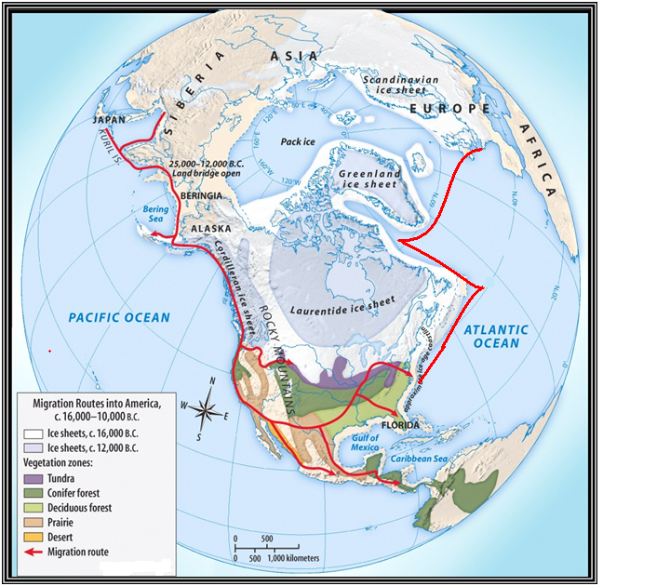
2
A
1

1. What is the title of this map? ___________________________________________________________________
2. The abbreviation “c.” is short for the Latin word circa, which translates to the English word “around”. Why do you think the mapmakers added this abbreviation before the dates? __________________________________________
3. In your own words, explain what happened to the area marked “A” between 16,000BC and 12,000 BC
_____________________________________________________________________________________________
4. People traveling along the migration route marked “1” came to the Americas from ________________
5. People traveling along the migration route marked “2” came to the Americas from ________________

Kennewick Man excerpt for collaborative annotation activity

The existence of Kennewick Man leads to the question: Who really discovered America? The conventional answer to that question dates to the early 1930s, when stone projectile points that were nearly identical began to turn up at sites across the American Southwest. They suggested a single cultural tradition that was christened Clovis, after an 11,000-year-old-plus site near Clovis, New Mexico. And because no older sites were known to exist in the Americas, scientists assumed that the Clovis people were the first to arrive. They came, according to the theory, no more than 12,000 years B.P. (before the present), walking across the dry land that connected modern Russia and Alaska at the end of the last ice age, when sea level was hundreds of feet lower than it is today.

Directions: As you look at the notes and comments left by other students, answer the following questions.

- What interesting things did you notice as you read the charts?

- What written items were listed on more than one chart?

- What was something that you expected or didn’t expect?

- What were some apparent patterns?

- What is a question that you still have?

Notes on Three Levels

Notes on Three Levels help you:
- identify important details and events, and
- determine why they are important or what they mean.
Use the sample “Deep Prompts” (or create your own) to help you answer the “Deep Questions” you pose.

Reflect on and summarize your notes…. (continue on the back if you need more space)
Sample Questions
______________________________________________
______________________________________________
______________________________________________
______________________________________________
______________________________________________
______________________________________________

Deep Prompts
______________________________________________
______________________________________________
______________________________________________
______________________________________________
______________________________________________
______________________________________________

______________________________________________
______________________________________________
______________________________________________
______________________________________________
______________________________________________
______________________________________________
______________________________________________
______________________________________________
______________________________________________
______________________________________________

Surface Questions/Observations
____________________________
____________________________
____________________________
____________________________
____________________________
____________________________

Deep Questions/Details
____________________________
____________________________
____________________________
____________________________
____________________________
____________________________

Support Your Thinking
(Use evidence from the text)
____________________________
____________________________
____________________________
____________________________
____________________________
____________________________
____________________________
____________________________
____________________________
____________________________

Notes on Three Levels

Notes on Three Levels help you:
- identify important details and events, and
- determine why they are important or what they mean.
Use the sample “Deep Prompts” (or create your own) to help you answer the “Deep Questions” you pose.

Reflect on and summarize your notes…. (continue on the back if you need more space)
Sample Questions
- How old are the pyramids?
- What did Alexander the Great accomplish?
- When did the Romans conquer Carthage?
- What happened during a medieval tournament?
- Where did the Renaissance begin?
- Who were the leaders of the Reformation?

Deep Prompts
- This proves that...
- This means that...
- The consequence of this is...
- This caused X to happen because...
- It acted this way because...
- This is important because it shows…

Surface Questions/Observations
- What is it?
- What did it do?
- What happened?
- Where did it happen?
- Who was involved?
- When did it happen?

Deep Questions/Details
• What does it mean?
• Why did it do that?
• What are the consequences?
• What will happen next?
• What caused this?
• Why is this important?

Support Your Thinking
(Use evidence from the text)
• What examples can you provide?
• Why do you think this is true?
• How do you know this?

