Christianity: Background, Basic Beliefs, and Sacred Texts
How did Christianity begin?
Christianity traces its beginning to the miraculous birth, adult ministry, death and resurrection of Jesus of Nazareth, known as Jesus Christ. Over 2000 years ago in Palestine (today's Israel), Jesus was born into a humble Jewish family. His mother was a young peasant woman named Mary. Christians believe that his father was the Holy Spirit of God, making Jesus both fully human and fully divine. His earliest followers came to believe that he was the Messiah, or messenger, sent by God to free God's people from slavery, sin, and death. Christian’s believe God sent his son Jesus in human form so that people would better understand God as a caring and loving parent. Jesus lived and experienced the suffering of humans. Jesus healed the sick and told stories, or parables, and preached sermons that taught what God wanted people to do – to love God with all their hearts and love their neighbors as themselves. Jesus taught by example. Christianity teaches followers that, by being loving and forgiving himself, Jesus taught others to be loving and forgiving - especially toward those who were considered outcasts in society. This is the central message and style of Jesus' teaching.
What do Christians believe?
Christians believe that Jesus Christ was the Son of God – fully human and fully divine – and that through believing in him and following his teachings they can inherit eternal life. Christians believe that Jesus died for humanity, that God raised him from the dead, and that Jesus will come again at the end of time. In addition, Christians believe in the Trinity, or the three parts of God: God the Father or Creator, God the Son (Jesus) or Redeemer, and God the Holy Spirit or Sanctifier. The Holy Spirit is God's presence in the world.
The essence of Jesus' teaching comes from the Jewish law he grew up with in the 10 Commandments with and these additional beliefs: *Love God with all your heart, soul and mind *Love and tolerance of all people
*Life after death was better than that on earth. * You do not have to be rich to be Christian
*Help the poor and sick *God is more powerful than leaders
What are the sacred texts of Christianity?
The sacred text of Christianity is the Holy Bible. The Christian Bible has two parts: the Old Testament which is essentially the Hebrew scripture, or the Torah, of Jesus' time; and the New Testament which contains writings about Jesus Christ and about the early church. The four gospels (a word meaning ‘good news') of the New Testament are accounts of Jesus' life and teaching, of his death and resurrection. The New Testament also contains the Acts of the Apostles, which describes the early growth of the Christian church; the letters of Paul and other important leaders in the early church; the Letter to the Hebrews; and the Book of Revelation. The New Testament teaches that salvation comes through believing in the death and resurrection of Jesus Christ and in following his teachings. It teaches that salvation is a gift God extends freely through Jesus Christ to all people.
Why are there so many different kinds of Christians?
From its beginning with a tiny group of Jesus' followers, Christianity has spread all over the world. Today, it is practiced by two billion people. As with any large group, Christianity has experienced many different interpretations, disagreements and struggles for power over the centuries. These have led to the growth of many different branches of Christianity interpreting the life, death and resurrection of Jesus in different ways. There are three basic streams of Christianity: Orthodox, Protestant and Roman Catholic.

Christian Sensory Figure

Directions: Using your notes, fill in the boxes below to describe what a Christian might see, hear, touch, and say. Be specific in your responses. Saying “With my eyes I see the busy street” is much too general and gives no specific details to the Christian faith. Include 3 descriptions per box. You don’t have to write in complete sentences but your thoughts must be clear.
With my eyes I see….
.
With my ears I hear….

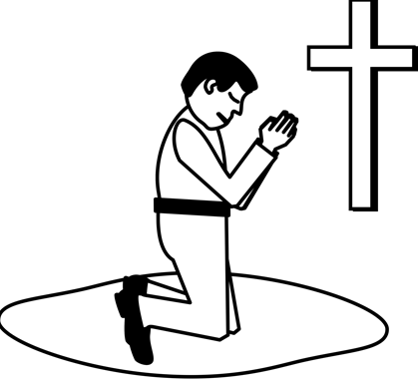
With my hands I touch…
With my mouth I say….
Christian

