Children’s Book—Rubric
50 Points Story/Plot covers: earth’s environmental problems, soil depletion, eating insects/bugs as solution
50 Points Uses a convincing tone
Written for an audience of about 7-8 year olds
At least 12-14 pages in length
Have text on each page
Have illustrations on 75% of pages, illustrations help tell the story
Have a cover with an original title and illustration
Look neat, and legible

Think about what is going to be on each page. What text/part of the story and what picture?
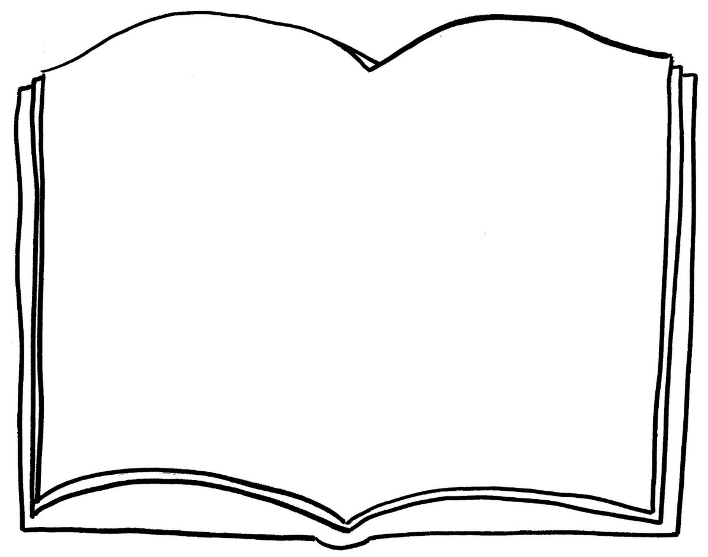

WHERE DOES THE TEXT GO? WHAT DOES THE TEXT SAY? WHAT PART OF YOUR STORY ARE YOU TELLING ON THIS PAGE? YOU CAN PUT IT WHEREVER YOU WANT TO ON THE PAGE?

