Building a shaduf

The challenge…if you choose to accept…Create an Ancient Egyptian inspired Shaduf with your team members. You are going to have a set time and set supplies to create this invention from Ancient History. You can only use the supplies provided by your teacher for this task!

A shaduf or water crane is a machine to move water from a lower place to a higher place. This hand-operated device used for lifting water was invented in ancient times and still is used today to irrigate land in some countries. Typically it consists of a long nearly horizontal pole mounted like a seesaw. A bucket is hung on a rope from the long end, and a counterweight is hung on the short end. The operator pulls down on a rope attached to the long end to fill the bucket and allows the counterweight to raise the bucket.

To successfully complete the task:

- Your model must be able to be pulled down into a source of water using a rope or string.
- Your bucket must be able to be filled with water.
- Your bucket must be able to be lifted out of the water source using only a counter weight (NOT A PERSON OR PERSON’S HAND)
- Bonus point if your final design can pivot.
- You must draw out/plan your design before beginning to create your shaduf. In this sketch, you need to label what supplies are going to be used for what pieces of this contraption.

BUT FIRST…you must answer the questions below in complete SENTENCES! Including lots and lots of details.
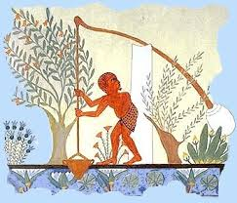
- What was the purpose of a shaduf? How did this invention benefit the Egyptian society?
- What does this invention show us about Egyptian society? Address the characteristics of the people living there during this time.
- What can we infer about Ancient Egypt based on the ideas of these inventions still being used today?
http://www.ancientvine.com/shaduf.html

