Architecture Notes
Architecture is the art and science of planning and creating buildings/structures.

The first written record of the theory of architecture was written by Vitruvius in the 1st Century. In his book, “De architectura” he summed up architecture as being a balance of, firmitatis, utilitatis, venustatis; Firmness (Structurally Sound/Durable), Commodity (Function/Use) and Delight (Beauty). Nothing has really changed regarding these fundamentals.

Pick the 2 civilizations you want to complete. You can only chose Rome OR Greece OR Egypt. You cannot pick 2 of those for your choices. The readings/information are on page 3 and 4.

As you read about the architecture of various ancient civilizations, determine the following:
- 1st Box: How did this civilization design its architecture so that it was structurally sound/firm/durable?
- 2nd Box: What function/purpose/use did the various pieces of architecture serve for the civilization?
- 3rd Box: How did the design show the civilization’s idea of beauty and their cultural values (what they care about)?
Mesopotamia
Structurally Sound/Firm/Durable | Function/Useful | Beautiful
Americas
Structurally Sound/Firm/Durable | Function/Useful | Beautiful
Egypt
Structurally Sound/Firm/Durable | Function/Useful | Beautiful

Greece
Structurally Sound/Firm/Durable | Function/Useful | Beautiful

Rome
Structurally Sound/Firm/Durable | Function/Useful | Beautiful

China
Structurally Sound/Firm/Durable | Function/Useful | Beautiful

Achievements in Architecture
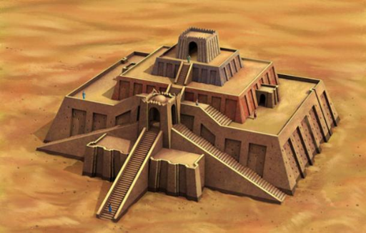
Mesopotamia
In the center of each town, was the Ziggurat. The Ziggurat was a temple. The ancient Sumerians, believed their gods lived in the sky. In order for the gods to hear better, you needed to get closer to them. Ziggurats were huge, with built in steps. The core of the ziggurat is made of mud brick covered with baked bricks laid with bitumen, a naturally occurring tar. Each of the baked bricks measured about 11.5 x 11.5 x 2.75 inches and weighed as much as 33 pounds. Ziggurats had a wide base that narrowed to a flat top. When the Babylonians took over in the south, and the Assyrians in the north, ziggurats continued to be built and used in the same manner as they were in ancient Sumer. The Ziggurat was the tallest building in the town. From its top, you could see well into the farmlands that surrounded the city. The largest ziggurat was probably the one built in ancient Babylon. The Assyrians also built ziggurats. Religious ceremonies were held on top of the Ziggurat. Each day, people would leave offerings to the gods of food, cloth, and wine on the steps of the ziggurat. The priests would collect and use these gifts since they were the representatives of the gods on earth.
Ancient Americas
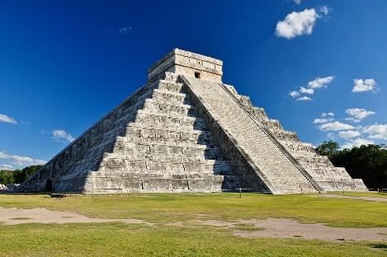
The Maya are perhaps most known for their many majestic stone pyramids. They built two kinds of pyramids. Both types of pyramids were similar in many ways. They each had the familiar pyramid shape. They each had steep steps up the side that would allow someone to climb to the top. They each were built for religious purposes and for the gods. Some pyramids feature an inner layer of mica (a shiny mineral) imported from Brazil 2,000 miles away without the benefit of wheeled transportation. However, they had their differences as well. The first type of pyramid had a temple on the top and was meant to be climbed by the priests to make sacrifices to the gods. The stairs going up the sides of these pyramids were steep, but not too steep for the priests to climb. The most important religious ceremonies were held at the top of these pyramids. The second type of pyramid was a sacred pyramid built to a god. These pyramids were not to be climbed or touched by humans. There were still steps going up the sides of these pyramids, but they were often too steep to climb without a lot of effort. These pyramids were sometimes built with secret doors, tunnels, and traps.
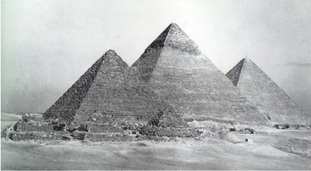
Egypt
The Ancient Egyptian pyramids are some of the most impressive structures built by humans in ancient times. Many of the pyramids still survive today for us to see and explore. The pyramids were built as burial places and monuments to the Pharaohs. As part of their religion, the Egyptians believed that the Pharaoh needed certain things to succeed in the afterlife. Deep inside the pyramid the Pharaoh would be buried with all sorts of items and treasure that he may need to survive in the afterlife.
Some of the earlier pyramids, called step pyramids, have large ledges every so often that look like giant steps. Archeologists think that the steps were built as stairways for the pharaoh to use to climb to the sun god. Later pyramids have more sloping and flat sides. These pyramids represent a mound that emerged at the beginning of time. The sun god stood on the mound and created the other gods and goddesses. There are around 138 Egyptian pyramids. Some of them are huge. The largest is the Pyramid of Khufu, also called the Great Pyramid of Giza. When it was first built it was over 480 feet tall! It was the tallest man-made structure for over 3800 years and is one of the Seven Wonders of the World. It's estimated that this pyramid was made from 2.3 million blocks of rock weighing 5.9 million tons.
How the pyramids were built has been a mystery that archeologists have been trying to solve for many years. It is believed that thousands of slaves were used to cut up the large blocks and then slowly move them up the pyramid on ramps. The pyramid would get slowly built, one block at a time. Scientists estimate it took at least 20,000 workers over 23 years to build the Great Pyramid of Giza. Because it took so long to build them, Pharaohs generally started the construction of their pyramids as soon as they became ruler. Deep inside the pyramids lays the Pharaoh's burial chamber which would be filled with treasure and items for the Pharaoh to use in the afterlife. The walls were often covered with carvings and paintings. Near the Pharaoh's chamber would be other rooms where family members and servants were buried. There were often small rooms that acted as temples and larger rooms for storage. Narrow passageways led to outside. Sometimes fake burial chambers or passages would be used to try and trick grave robbers. Because there was such valuable treasure buried within the pyramid, grave robbers would try to break in and steal the treasure. Despite the Egyptian's efforts, nearly all of the pyramids were robbed of their treasures by 1000 B.C.
Greece
The ancient Greeks were wonderful architects. They invented three types of columns to support their buildings. Each was beautiful. From a distance, each column looked straight, no matter which of the three designs they used. But up close, the columns might actually tilt a bit, or lean left or right, to better support each building. The Greeks wanted things to be beautiful, but they also wanted things to be strong. Nearly every public building in ancient Greece incorporated one or more of these three designs. These designs are still used today. These designs have certainly withstood the test of time.
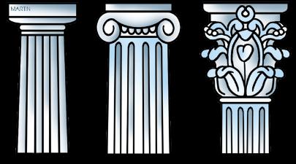
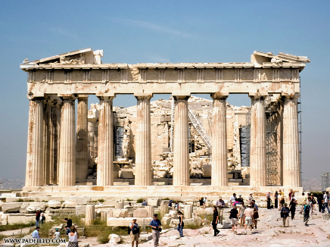
Doric: The Doric order is the oldest and most simple order. The columns have no base and the columns have a very simple capital. In other words, Doric buildings were the least decorated. Archaeologists believe that Doric architectural buildings, which were built in stone, evolved from wooden buildings that were very similar.
• Ionic: The Ionic order is more decorative than the Doric. The columns are taller and thinner, and the capitals at the top of the columns are decorated with scrolls and other patterns. The bases of the columns are also decorated.
• Corinthian: The Corinthian order is a lot like the Ionic order, but the capitals are even more elaborately decorated (more fancy), usually with leaves and floral patterns.
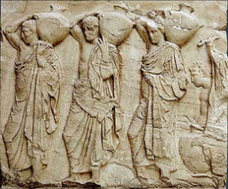
One example of architecture using Greek columns is the Parthenon constructed between 447-432 BCE. The Parthenon was a temple to the goddess Athena. It was built on top of a hill called the Acropolis. You could see it from all over Athens. Inside the Parthenon there was a huge gold statue of the goddess Athena. Outside the Parthenon, high up on its four walls there was a frieze. This frieze was a series of sculptures that went all the way round the building. These sculptures were not added to the building. The sculptors actually cut the frieze out of the very stone which formed the walls of the building. Many people think that this frieze is one of the most wonderful works of art ever created. The Parthenon’s massive foundations were made of limestone, and the columns were made of Pentelic marble, a material that was utilized for the first time.
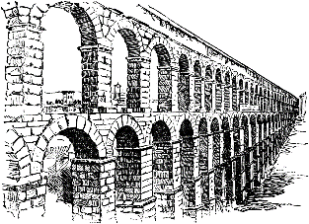
Rome
How did the ancient Romans deal with plumbing? They built huge and extensive aqueducts, or waterways. These under and aboveground channels, typically made of stone, brick, and volcanic cement, brought fresh water for drinking and bathing as much as 50 to 60 miles from springs or rivers. Aqueducts helped keep Romans healthy by carrying away used water and waste, and they also took water to farms for irrigation. So how did aqueducts work? The engineers who designed them used gravity to keep the water moving. If the channel was too steep, water would run too quickly and wear out the surface. Too shallow, and water would stagnate and become undrinkable. The Romans built tunnels to get water through ridges, and bridges to cross valleys. Once it reached a city, the water flowed into a main tank called a castellum. Smaller pipes took the water to the secondary castella, and from those the water flowed through lead pipes to public fountains and baths, and even to some private homes. It took 500 years to build Rome’s massive system, which was fed by 11 separate aqueducts. To this day, Rome’s public fountains run constantly, as do smaller faucets that provide fresh water to anyone who stops for a drink. The empire stretched across an immense part of the world, and wherever the Romans went they built aqueducts — in as many as 200 cities around the empire. Their arched bridges are among the best preserved relics of that empire, in part because many aqueducts kept working for centuries, long after the Romans had retreated. You can still see their arches in Bulgaria, Croatia, France, Germany, Greece, Israel, Lebanon, Spain, Tunisia, and other former Roman colonies.
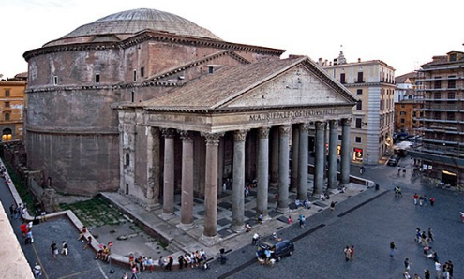
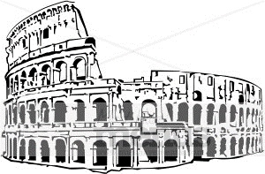
The Colosseum was situated in the center of Rome, it was in fact a symbol of the might, wealth and power of the Roman Empire. The Colosseum took less than 10 years to build, a remarkable achievement for the excellent engineers and their famous engineering skills. The architecture of the Colosseum (as well as the Pantheon and Roman Forum) illustrates their use of one of the Romans most famous inventions - concrete. The Romans first began building with concrete over 2,100 years ago and used it throughout the Mediterranean basin in everything from aqueducts and buildings to bridges and monuments. Roman concrete was considerably weaker than its modern counterpart, but it has proved remarkably durable thanks to its unique recipe, which used slaked lime and a volcanic ash known as pozzolana to create a sticky paste. Combined with volcanic rocks called tuff, this ancient cement formed a concrete that could effectively endure chemical decay. Pozzolana helped Roman concrete set quickly even when submerged in seawater, enabling the construction of elaborate baths, piers and harbors. The Roman arch was also prominently featured in the design and building of the Colosseum as were the different styles of columns.
In Rome today, there still exists one of the most spectacular examples of Roman architecture. This is the Grand Pantheon. The Grand Pantheon, which means “Temple of all the gods,” was built in the early days of the empire. It was constructed to be a temple for all the Roman gods. The structure is a hundred and fifty-eight feet high, and about the same width. The dome of the Pantheon, which was made from concrete, is still one of the largest single-span domes in the world. There are no windows in the whole of the Pantheon, only a round hole at the top of the roof, which serves very well for the admission of light.
China
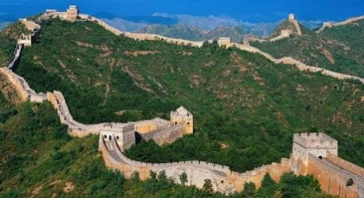
The Great Wall of China is a series of fortifications made of stone, brick, tamped earth, wood, and other materials, generally built along an east-to-west line across the historical northern borders of China. It was built to keep invaders out of China. The wall is not straight. It curves a great deal and is 4,500 miles long! It is approximately 25 feet tall and between 25 and 30 feet wide (that is wide enough for two cars to drive on side-by-side). Furthermore, ancient records show that over 350,000 people, mostly soldiers worked on the Great Wall. It took approximately 200 years to build the Great Wall. Work on the Wall continued during all four seasons, even in the heat and bitter cold.

