**Architecture DBQ**

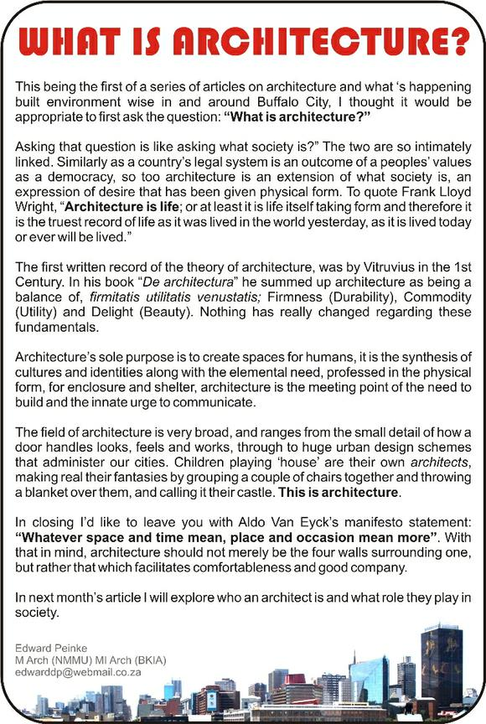

1. What is the definition of architecture? ____________________________________________________

_____________________________________________________________________________________

2. Vitruvius said architecture is a balance of ______________________, ___________________________

and __________________________________.

3. Combine your answers to #1 and #2 to write a brief summary of the reading.

_______________________________________________________________________________________

_______________________________________________________________________________________

_______________________________________________________________________________________

_______________________________________________________________________________________

**PYRAMIDS**

[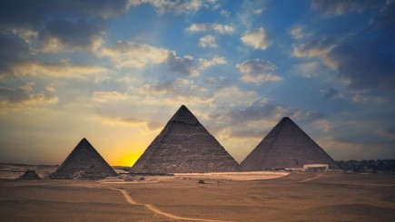](https://www.google.com/streetview/#pyramids-of-giza/pyramid-of-khufu)

**AZTEC**

**MAYA**

[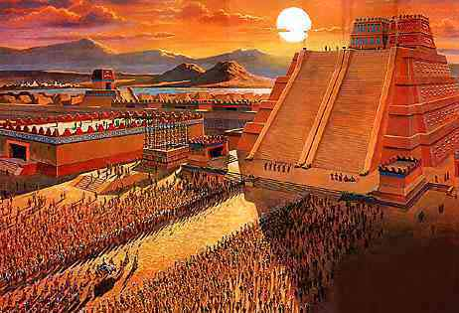](http://krazy4facts.tripod.com/id19.html)[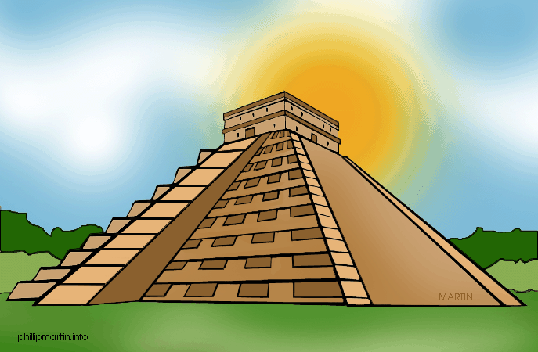](http://video.nationalgeographic.com/video/ancient-mysteries/chichen-itza-temples)

**EGYPT**

***Click on one of the pyramids (Ctrl + Click Scroll) and answer the questions:***

1. Describe the pyramid you chose with three adjectives _____________________________,

________________________________ and __________________________________.

2 Choose one of the three principles of Vitruvius that best applies to this pyramid.

____________________________________________________

3. Use your three adjectives to briefly explain why you chose your answer to #2.

_______________________________________________________________________________________

_______________________________________________________________________________________

_______________________________________________________________________________________

_______________________________________________________________________________________

_______________________________________________________________________________________

_______________________________________________________________________________________

**TEMPLES**

[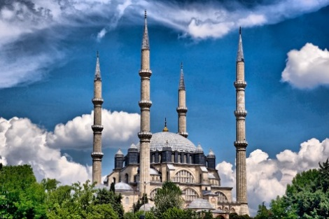](https://www.youtube.com/watch?v=oAPvIbsuACo)[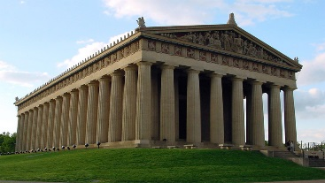](https://www.youtube.com/watch?v=zQPbGYR1jgs)[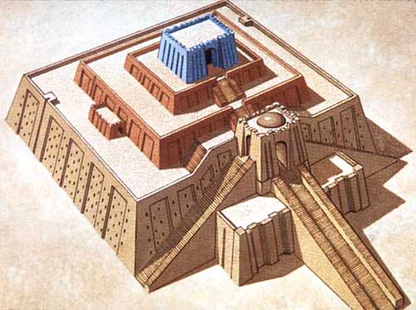](https://www.youtube.com/watch?v=oGW903mfabY)

**MESOPOTAMIAN**

**ZIGGURAT**

**ANCIENT GREECE**

**ISLAMIC MOSQUE**

***Click on one of the temples (Ctrl + Click Scroll) and answer the questions:***

1. Describe how the temple you chose reflects the religious beliefs of the society that built it.

____________________________________________________________________________________

____________________________________________________________________________________

____________________________________________________________________________________

2. Was the temple you chose built by a monotheistic or a polytheistic society? (Circle one)

3. Use at least two complete sentences to explain how this temple might be different if it were built by a society that had the other type of religion. (For example, if it was built by a **mono**theistic society, how would it have been different if it was built by a **poly**theistic society?)

_______________________________________________________________________________________

_______________________________________________________________________________________

_______________________________________________________________________________________

_______________________________________________________________________________________

_______________________________________________________________________________________

_______________________________________________________________________________________

_______________________________________________________________________________________

_______________________________________________________________________________________

**MONUMENTS**

[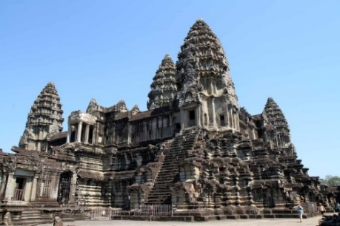](https://www.google.com/streetview/#angkor-wat/towers-of-angkor-wat)[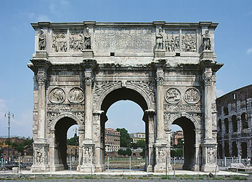](http://lookrome.com/en/place/monuments-in-rome/tour-virtuale-3d-arco-di-costantino.html)[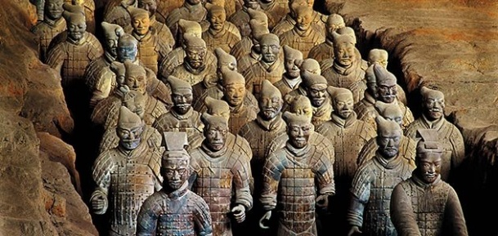](https://www.youtube.com/watch?v=RsUE-ZtcUFg)

**ANGKOR WAT**

**CAMBODIA**

**ANCIENT ROME**

**ARCH OF CONSTANTINE**

**ANCIENT CHINA**

**TERRACOTTA WARRIORS**

***Click on one of the monuments (Ctrl + Click Scroll) and answer the questions:***

1. Describe how the monument you chose reflects the cultural values of the people that built it.

_____________________________________________________________________________________

_______________________________________________________________________________________

_______________________________________________________________________________________

2. Does this monument primarily relate to government, religion, or art? (Circle one)

3. In the first reading, architecture is described as “the meeting point of the need to build and the innate urge to communicate”. (*Innate refers to something you are born with.*) Describe how the monument you chose fits those two ideas.

How does it show the society’s need to build?

_______________________________________________________________________________________

_______________________________________________________________________________________

_______________________________________________________________________________________

How does it show the society’s need to communicate?

_______________________________________________________________________________________

_______________________________________________________________________________________

_______________________________________________________________________________________

Use the answers to all your previous questions to write a paragraph with the following topic sentence.

**“Architecture reflects the values of civilizations, societies, and regions.”**

**In your paragraph, be sure to include:**

* **The topic sentence written above**
* **Supporting details about all three buildings you studied**
* **A reference to information from the article titled “What is architecture?”**
* **A closing statement in which you draw a conclusion.**

**__________________________________________________________________________________________________**

**__________________________________________________________________________________________________**

**__________________________________________________________________________________________________**

**__________________________________________________________________________________________________**

**__________________________________________________________________________________________________**

**__________________________________________________________________________________________________**

**__________________________________________________________________________________________________**

**__________________________________________________________________________________________________**

**__________________________________________________________________________________________________**

**__________________________________________________________________________________________________**

**__________________________________________________________________________________________________**

**__________________________________________________________________________________________________**

**__________________________________________________________________________________________________**

**__________________________________________________________________________________________________**

**__________________________________________________________________________________________________**

**__________________________________________________________________________________________________**

**__________________________________________________________________________________________________**

**__________________________________________________________________________________________________**

**Articles linked in the DBQ – next to each hyperlinked picture is a clipart of a small scroll. By clicking that scroll, the student will be taken to a brief article about the building shown in the picture.**

**Egyptian Pyramids**

<http://www.kidspast.com/world-history/0075I-pyramid-of-giza.php>

**Mayan Pyramids**

<http://www.ducksters.com/history/maya/pyramids_and_architecture.php>

**Aztec Pyramids**

<http://www.aztec-history.com/aztec-temples.html>

**Ziggurat**

<http://mesopotamia.mrdonn.org/ziggurats.html>

**Parthenon**

<http://study.com/academy/lesson/parthenon-facts-lesson-for-kids.html>

**Selimeye Mosque, Turkey**

<http://lostislamichistory.com/the-greatest-architect-of-all-time/>

**Terra Cotta Warriors, China**

<http://www.ducksters.com/history/china/terracotta_army.php>

**Arch of Constantine, Rome**

<http://www.ancient-rome-history-facts.com/Famous-Ancient-Roman-Architecture-Facts/Arch-of-Constantine-Facts.shtml>

**Angkor Wat, Cambodia**

<http://mocomi.com/angkor-wat/>