Archeologist
Investigation

Period of History: Byzantine Empire
Original Location of Items: buried trash dump in Istanbul (outside ancient city of Constantinople)
Approximate Age of Items: between 600-1500 years old
Mission:
Goals
-To identify and make sense of artifacts/items found in the trash dump.
-To analyze and understand significance to the Byzantine Empire.
-To increase our knowledge of life in the Byzantine Empire.

Task: Analyze the discovered items, complete the analysis questions, and make your predictions.

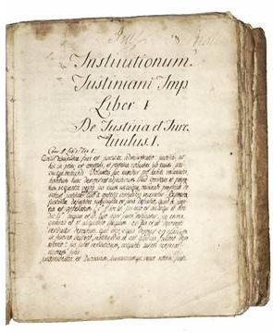
Item # 1
Describe what you see: ____________________________________
____________________________________________________________
____________________________________________________________
What is your prediction for what this item is? __________________________________________________________________
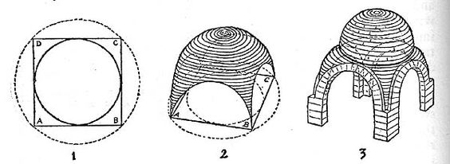
Why do you think this is important to the Byzantine Empire? ___________________ ____________________________________________________________________________________________________________________________________________________________
Item #2
Describe what you see: _______________________ ____________________________________________________________________________________________________________________________________
What is your prediction for what this item is? ______________________ __________________________________________________________________
Why do you think this is important to the Byzantine Empire? _______ ____________________________________________________________________________________________________________________________________
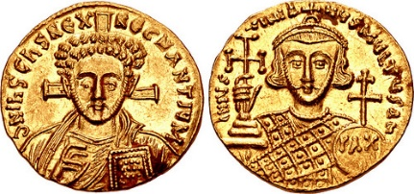
Item # 3
Describe what you see: ____________________________ ___________________________________________________
__________________________________________________________________
What is your prediction for what this item is? ______________________
Why do you think this is important to the Byzantine Empire? _______ ____________________________________________________________________________________________________________________________________
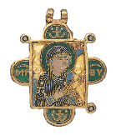
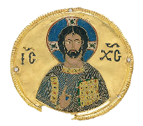
Item #4
Describe what you see: ___________________________________________ __________________________________________________________________
What is your prediction for what this item is? ______________________ __________________________________________________________________
Why do you think this is important to the Byzantine Empire? _______ ____________________________________________________________________________________________________________________________________
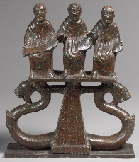
Item #5
Describe what you see: _________________________________ ________________________________________________________
What are the 3 men holding and what purpose could that have? __________________________________________________________________
What is your prediction for what this item is? ______________________ __________________________________________________________________
Why do you think this item is important to the Byzantine Empire? ____________________________________________________________________________________________________________________________________
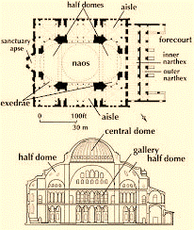
Item #6
Describe what you see: ________________________________ ________________________________________________________
What is your predication for what this item is? _________ ________________________________________________________
Why do you think this item is important to the Byzantine Empire? ____________________________________________________________________________________________________________________________________
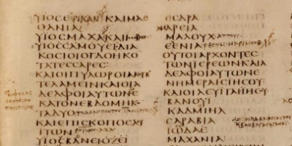
Item # 7
Describe what you see: ____________________________ __________________________________________________________________
What is your prediction for what this item is? ______________________ __________________________________________________________________
Why do you think this item is important to the Byzantine Empire? ____________________________________________________________________________________________________________________________________
Byzantine Sports Beat
Yesterday was another full capacity day at the Hippodrome as 100,000 anxious fans packed the sporting arena to witness the chariot races. As is customary, citizens of all classes received a free token to enjoy the games. The crowd went wild when Emperor Justinian entered the stadium dressed in imperial robes and signaled the start of the races by dropping a white napkin. Once again, the teams consisted of the Blues, Greens, Reds, and Whites who raced numerous exciting matches. The Blues, wearing billowing garments, seemed larger than life. All of the teams carried weapons under their clothes in case violence erupted. Luckily, none did, and it was a relatively riot-free day in the Hippodrome with the Blues winning!
Item # 8
Describe does this item describe: _______________________ __________________________________________________________________________________________________________________________
What is your prediction for what this item is? _________________ _____________________________________________________________
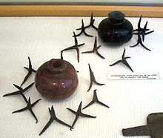
Why do you think this item is important to the Byzantine Empire? ____________________________________________________________________________________________________________________________________

Item # 9
Describe what you see: _____________________________________ __________________________________________________________________
What is your prediction for what this item is? ______________________ __________________________________________________________________
Why do you think this item is important to the Byzantine Empire? ____________________________________________________________________________________________________________________________________

