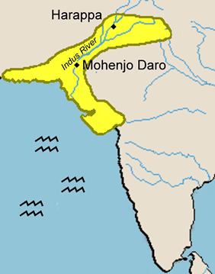
Ancient India: Harappa and Mohenjo-Daro
You will: Step into the role of an archaeologist studying the ancient cities of Harappa and Mohenjo-Daro.
Using resources from the web, draw conclusions and develop theories about life in the ancient Indus River Valley.
Use the information on the suggested Internet sites (see my website for the links) to draw conclusions about how particular evidence from the cities of the ancient Indus River Valley shapes our understanding of that civilization. Write a conclusion for each day's description of artifacts found while studying the remains of these ancient cities.

DAY 1: "Glacier-draped mountains surround the ruins of this ancient city. The Hindu Kush and Himalaya Mountains are particularly ominous with their jagged peaks. A colleague on the dig that knows the Indian Sanskrit language told me that 'Kush' means 'death.' Spring is approaching and the melting snows from the mountain ranges are beginning to melt into the Indus River." (see slide #5 on the Ancient Indus Tour site)
CONCLUSION:

DAY 2: "Inside Harappa to the right of the gateway is an area where large quantities of manufacturing debris were unearthed. We found remnants of stone weights, shell ornaments, and stone tools." (see slide #21 on the Ancient Indus Tour site)
CONCLUSION:

DAY 3: "In one dwelling spot I found an entire collection of seals and tablets. The seals were made of soapstone and had detailed engravings of animals and writing that we cannot decipher." (see slides #24, #25, and #30 on the Ancient Indus Tour site)
CONCLUSION:

DAY 4: "Mohenjo-Daro seems to be divided into two districts, a citadel and a residential lower city. The buildings are made of fired-brick, and there are remains of wells and evidence of an extensive drainage system. The lower city is laid out in a grid pattern. The wide streets cross one another at exact right angles. The precision is remarkable!" (see slides #9, #10, and #12 on the Ancient Indus Tour site)
CONCLUSION:

DAY 5: "Extensions of low walls made of baked brick could be the outlines of a communal sewer system. Most dwelling sites appear to contain either indoor or outside bathing facilities." (see slides #12 and #14 on the Ancient Indus Tour site)
CONCLUSION:

DAY 6: "Clay figurines of animals are everywhere. We have found majestic images of the 'zebu bull' in both Harappa and Mohenjo-Daro, but not in the smaller villages between the two. Stone seals picture a variety of domesticated and wild animals. I have seen rhinoceroses, tigers, elephants, and oxen." (see slides #27and #28 on the Ancient Indus Tour site)
CONCLUSION:

DAY 7: "One of the largest clay figurines that we have found in Harappa was a female with three sets of chokers and necklaces. It had the common fan-shaped headdress with cups on either side that showed traces of black pigment or soot." (see slide #50 on the Ancient Indus Tour site)
CONCLUSION:

