Egypt Test
I. Document Analysis
Read the following document then answer the questions that follow.
A Scribal Book, 12th century, New Kingdom
See for yourself with your own eye. The occupations lie before you.
The washerman’s day is going up, going down. All his limbs are weak, whitening his neighbors’ clothes every day, from washing their linen. The maker of pots is smeared with soil. His hands, his feet are full of clay; he is like one who lives in the bog. The cobbler mingles with vats ₁. His odor is penetrating. His hands are red with madder ₂, like one who is smeared with blood… The merchant travels downstream and upstream. They are as busy as can be, carrying goods from one town to another. The tax collectors carry off the gold, that most precious of metals. The ships’ crews from every business], they receive their loads. They depart from Egypt for Syria, and each man’s god is with him. But not one of them says “We shall see Egypt again!” The carpenter who is in the shipyard carries the timber and stacks it. If he works as hard today as the work yesterday, woe to his limbs! The shipwright stands behind him to tell him evil things. His worker who is in the fields, his is the toughest of all the jobs. He spends the day loaded with his tools, tied to his tool-box. When he returns home at night, he is loaded with the tool-box and the timbers, his drinking mug, and his whetstones ₃.
The scribe, he alone, records the work of all them. Take note of it!

A Scribal Boo

₁ vats- large barrels for tanning leather
₂ madder- a red plant dye
₃ whetstones- stones for sharpening knives or tools

Questions:
1. Highlight 5 different jobs listed above.

2. What do scribes do according to this document? Circle it with your marker

3. How is being a scribe different from the other jobs listed? ________________________________________
______________________________________________________________________________________________________________________________________________________________________________________________________________________________________________________________________________

4. According to the document, what were the cobbler’s hands covered in?
a. vats c. madder
b. blood d. clay

Use the chart to answer the questions that follow.
The Nile River Flood Cycle
When
June- October

October- February

February- June

What Happens
Fields are flooded and fertilized by the new batch of rich silt. Time when many farmers did jobs like canal repair, quarrying, and pyramid building.
Waters receded but Nile high enough to fill irrigation canals; crops were planted and tended.
Crops are harvested and sent to market.
Season
Akhet
(flooding) rainy

Peret
(growing) mild weather
Shemu
(harvest) very hot

Questions:
5. During what season were crops planted? ______________________________________
6. What might happen if during Akhet the Nile’s floods were not as high? How would that affect what happens during the other two seasons? __________________________________________________________________________________________
____________________________________________________________________________________________________________________________________________________________________________________
7. 95% of Egypt’s population was farmers. According to the chart, during what season did farmers work in the fields the least? EXPLAIN______________________________________________________________________
__________________________________________________________________________________________

Question:
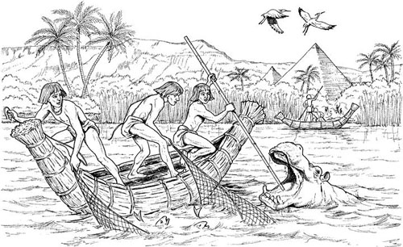
8. Using the picture, circle 3-4 “gifts” or benefits of the Nile with a marker. Then write a complete sentence using your evidence. Start your sentence with “Without the Nile, Egypt…”
_______________________________________________________________________________________________________________________________________________________________________________________________________________________________________________________________________________________________

III. Reading Charts & Graphs
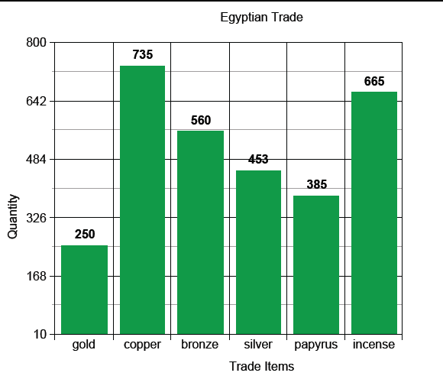
9. Which trade item had the highest supply? ______________________________
10. How many gold and bronze items in total were traded? ______________________________
11. Based on this chart, what can you infer about Egyptian trade?
a. Copper was in high demand.
b. Papyrus was expensive.
c. Egyptians didn’t like bronze.
d. Linen cloth was also traded.

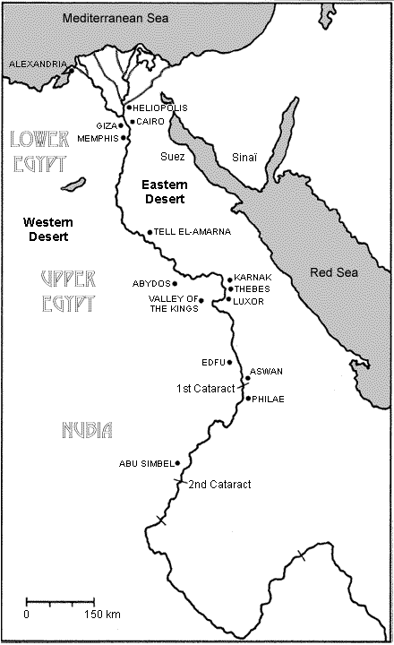

IV. Map Skills
N
12. Label the Red Sea &Mediterranean Sea.

13. Shade in the delta with blue or green.

14. Why is Lower Egypt in the north and
Upper Egypt in the south?
____________________________________
____________________________________
____________________________________

15. What is one effect the desert had on
Ancient Egyptians (positive or negative)?
____________________________________
____________________________________
____________________________________
____________________________________
16. Why do you think all of Egypt’s cities
are located along the Nile?
__________________________________
__________________________________
___________________________________________

V. Text Comparison:
Use the texts below to answer the following questions.
Source 1: Diary of archaeologist Howard Carter’s Discovery of King Tut’s tomb, November 26, 1922
“With the light of an electric torch as well as an additional candle we looked in.
Our sensations and astonishment are difficult to describe as the better light revealed to us the marvelous collection of treasures: two strange ebony-black effigies (head sculptures) of a King, gold-sandaled, bearing staff and mace, loomed out from the cloak of darkness; golden couches in strange forms, lion-headed, Hathor-headed, and beast infernal; exquisitely painted, inlaid, and ornamental caskets; alabaster vases, some beautifully executed of lotus and papyrus device; strange black shrines, with a gilded monster snake appearing from within; quite ordinary looking white chests; finely carved chairs; a golden inlaid throne; beneath our very eyes, on the threshold, a lovely goblet in translucent alabaster; and, lastly, parts of chariots glinting with gold...”
Source 2: news article, LA Times, Sept. 8th, 2014

The mummification process is sophisticated. First, it requires the use of special materials, called embalming agents.
During funeral ceremonies, embalming agents would be injected into the body. The chemicals in the agents would keep the body looking similar to how it looked when it was alive.
Mummification also involved wrapping bodies in funeral cloth for further protection.
The ancient Egyptians did all of this to prepare bodies for the afterlife.
Archaeologists previously believed that the early Egyptians did not understand how to use embalming chemicals to preserve bodies as far back as 4300 B.C.
Rather, archaeologists thought that the bodies found during this time period were accidentally preserved by Mother Nature. The hot, desert climate of ancient Egypt was full of dry sand and wind. These natural elements can protect a buried body in ways similar to mummification.

17. What do both of these articles tell us about Egyptian beliefs of the afterlife?
A. They valued golden treasures and mummification was a simple process.
B. They only mummified pharaohs and only buried canoes with them to sail down the Nile.
C. They believed they could take their belongings with them to the afterlife and that their bodies needed to be preserved.
D. Lower classes of Egyptians could not afford proper mummification like the pharaohs.

18. According to Source 2, what is the purpose of embalming agents?
A. to make the body smell good. B. to keep the evil spirits away.
C. to keep the skin smooth. D. to dry out the insides of the body for preservation.

Egypt Test
I. Document Analysis
Read the following document then answer the questions that follow.
A Scribal Book, 12th century, New Kingdom
See for yourself with your own eyes. The jobs that you see daily.
The washerman’s day is walking back and forth to the river, washing his neighbors’ clothes every day. The potter is dirty with soil. His hands, his feet are covered in clay. The shoemaker works with vats ₁. His smell is awful. His hands are red with madder ₂, like one who is smeared with blood… The merchants travel downstream and upstream. They are as busy as can be, selling goods from town to town. The tax collectors collect the heavy gold. The tired carpenter carries the wood and stacks it all day. The farmer in the fields has the toughest job of all. He spends the day loaded with his tools, tied to his tool-box. When he returns home at night, he is still loaded with the tool-box and the timbers, his drinking mug, and his whetstones ₃.
Only the scribe records the work of all them. Remember this!

A Scribal Boo

₁ vats- large barrels for tanning leather
₂ madder- a red plant dye
₃ whetstones- stones for sharpening knives or tools

Questions:
1. Highlight 5 different jobs listed above.

2. What do scribes do according to this document? Circle it with your marker

3. Is a scribe easier or harder than the other jobs listed? Explain ______________________________________
______________________________________________________________________________________________________________________________________________________________________________________________________________________________________________________________________________

4. According to the document, what were the shoemaker’s hands covered in?
a. vats c. madder
b. blood d. clay

Use the chart to answer the questions that follow.

The Nile River Flood Cycle
When
June- October

October- February

February- June

What Happens
Fields are flooded and fertilized by silt. Time when many farmers did jobs like canal repair, quarrying, and pyramid building.
Flood is over but Nile high enough to fill irrigation canals; crops were planted and taken care of.
Crops are picked and sent to market.
Season
Akhet
(flooding) rainy

Peret
(growing) mild weather
Shemu
(harvest) very hot

Questions:
5. During what season were crops planted? ______________________________________

6. What is a difference you see between the Nile’s flood cycle and our seasonal calendar in the US?
a. We don’t have a good season for growing crops.
b. The Egyptian calendar does not have a hot season.
c. We both have a harvest season
d. Our harvest season is between August-October, not February-June like in Egypt.

7. Most Egyptians were farmers. According to the chart, during what season did farmers work in the fields the least? EXPLAIN. __________________________________________________________________________________________
__________________________________________________________________________________________

II. Using Evidence
8. Using the picture, circle 3 “gifts” or benefits of the Nile with a marker. Then write a complete sentence using your evidence. Start your sentence with “Without the Nile, Egypt…”
____________________________________________________________________________________________________________________________________________________
III. Reading Charts & Graphs
9. Which trade item had the highest supply? ______________________________
10. How many gold and bronze items in total were traded? ______________________________
11. Based on this chart, what can you infer about Egyptian trade?
a. Copper was in high demand.
b. Papyrus was expensive.
c. Egyptians didn’t like bronze.
d. Linen cloth was also traded.

IV. Map Skills

12. Label the Red Sea &Mediterranean Sea.
N

13. Shade in the delta with blue or green.

14. Is Lower Egypt in the north or the south?
____________________________________

15. What is one effect the desert had on
Ancient Egyptians (positive or negative)?
____________________________________
____________________________________
____________________________________
____________________________________
16. Where are most of Egypt’s cities located?
__________________________________
__________________________________

V. Text Comparison:
Use the texts below to answer the following questions.
Source 1: Diary of archaeologist Howard Carter’s Discovery of King Tut’s tomb, November 26, 1922
“With the light of an electric torch as well as an additional candle we looked in.
Our sensations and astonishment are difficult to describe as the better light revealed to us the marvelous collection of treasures: two strange ebony-black effigies (head sculptures) of a King, gold-sandaled, bearing staff and mace, loomed out from the cloak of darkness; golden couches in strange forms, lion-headed, and beast; exquisitely painted, carved, and ornamental caskets; alabaster vases, some beautifully painted with lotus, and papyrus device; strange black shrines, with a golden monster snake appearing from within; quite ordinary looking white chests; finely carved chairs; a golden throne; beneath our very eyes, on the threshold, a lovely goblet in translucent alabaster; and, lastly, parts of chariots glinting with gold...”
Source 2: news article, LA Times, Sept. 8th, 2014

The mummification process is sophisticated. First, it requires the use of special materials, called embalming agents.
During funeral ceremonies, embalming agents would be injected into the body. The chemicals in the agents would keep the body looking similar to how it looked when it was alive.
Mummification also involved wrapping bodies in funeral cloth for further protection.
The ancient Egyptians did all of this to prepare bodies for the afterlife.
Archaeologists previously believed that the early Egyptians did not understand how to use embalming chemicals to preserve bodies as far back as 4300 B.C.
Rather, archaeologists thought that the bodies found during this time period were accidentally preserved by Mother Nature. The hot, desert climate of ancient Egypt was full of dry sand and wind. These natural elements can protect a buried body in ways similar to mummification.

17. What do both of these articles tell us about Egyptian beliefs of the afterlife?
A. They valued golden treasures and mummification was a simple process.
B. They believed they could take their belongings with them to the afterlife and that their bodies needed to be preserved.
C. Lower classes of Egyptians could not afford proper mummification like the pharaohs.

18. According to Source 2, what is the purpose of embalming agents?
A. to keep the evil spirits away.
B. to keep the skin smooth.
C. to dry out the insides of the body for preservation.

