Ancient Greece Vocabulary
Reference Sheet
Acropolis-the steep-sided hill in the center of the city that is walled and holds the most important temples for the gods and goddesses.
Then: Now:

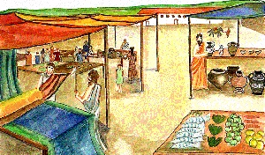
Agora-the large open area that was the main marketplace. People sold and bought things hear that they needed.
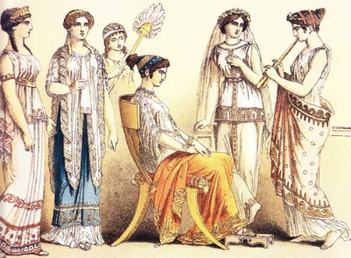
Aristocracy-the people in the highest class; the wealthy people
with power.
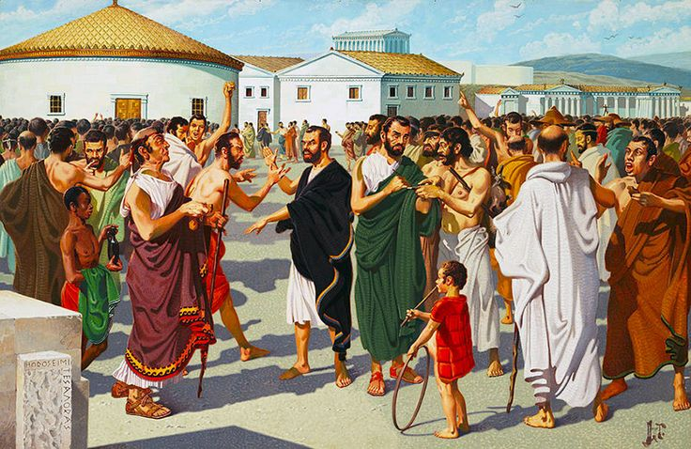
Assembly-the opportunity for male citizens to come together, say their opinions, and vote on certain matters.

Democracy-any male citizen could participate in
the voting process on main issues in the government.

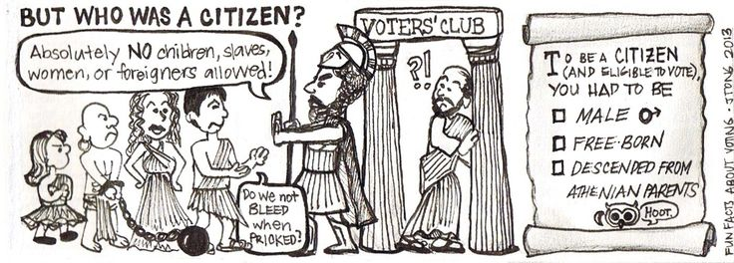

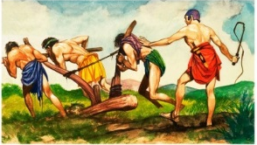
Helot-were slaves, people of the lowest class. They were slaves because they were subjugated (put beneath somebody and controlled) by the Spartan people.

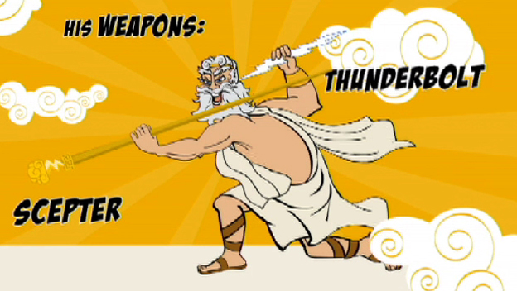
Myth-a tradition, legend, and/or story that the Ancient
Greeks believed as part of their culture and religion.
Myths are usually fiction and did not actually happen.
They have to do with gods/goddesses, how they came to
be, and why they do the things they do.
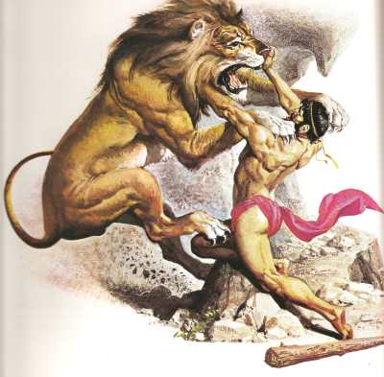

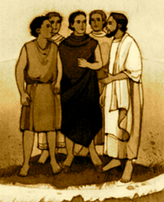
Oligarchy-a type of government that is ruled by a few people.
These people are almost always from the powerful, wealthy, class.
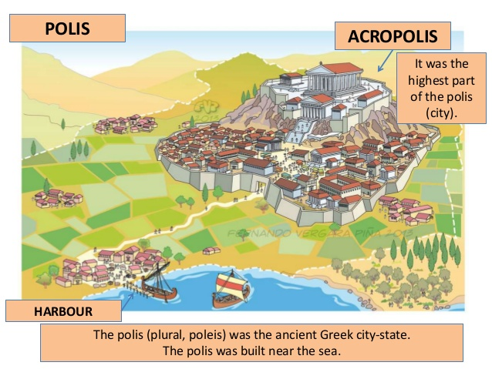
Polis-the structure of a community in Ancient Greece. It consisted of a city with a sacred and valued center in the center and high up (acropolis), and controlled the surround area. A synonym for polis is city-state, but the polis makes sure to include in the definition the acropolis that is in the center of the city.

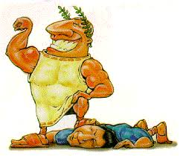

Tyrant-someone who takes power for himself usually by overthrowing/taking over the government, not by election, vote, or being born into the position. Often times this purpose is a military leader. The tyrant holds absolute power.

